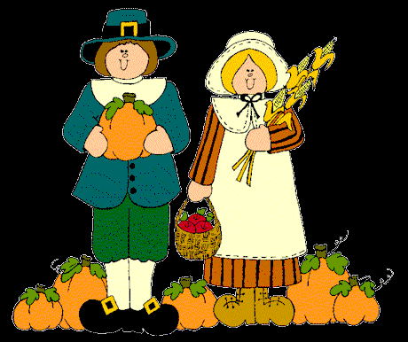
*The following skit is written as a narration, with one adult or older child reading the script while younger children and family members act out the story.*
A Thanksgiving Day Skit
Many years ago, the Pilgrims prayed for a place to live where they could worship God and go to church.
So they decided to come to America. They sailed on a big ship called the Mayflower.
It took great courage for the Pilgrims to cross the ocean. There were many dangers and the boat was cramped. There weren't showers on the Mayflower, so it was probably pretty smelly, too.
When they landed in America, the Pilgrims needed food to eat. They looked for fresh food in the forest.
They gathered seeds and berries.
But soon the weather began to change. The first winter that the Pilgrims lived in America was very long, very cold, and very difficult.
Many of the Pilgrims became ill.
When Spring finally came, it was a time of joy!
One day, a kind Indian walked into the Pilgrim's village. He liked the Pilgrims and wanted to help them.
Soon, more Indians came. They were nice and showed the Pilgrims how to fish, plant corn, and build homes.
The Pilgrims taught the Indians about God and how much He loves them.
One of the Indians was called Squanto. He was their special friend.
Together they hunted quail and turkey. The Pilgrims would be ready, this time, for the coming winter.
When summer ended, the Pilgrims wanted to have a feast.
They had plenty of food and many new friends. They wanted to give thanks to God for all of their blessings.
"Join us!" the Pilgrims said to the Indians, "Join us in a big feast of Thanksgiving! It will be a very special holiday."
The Indians came to the feast. Long tables were filled with delicious things to eat.
Everyone was so excited and everyone gave thanks to our Father.
What a wonderful first Thanksgiving Day!
The End.
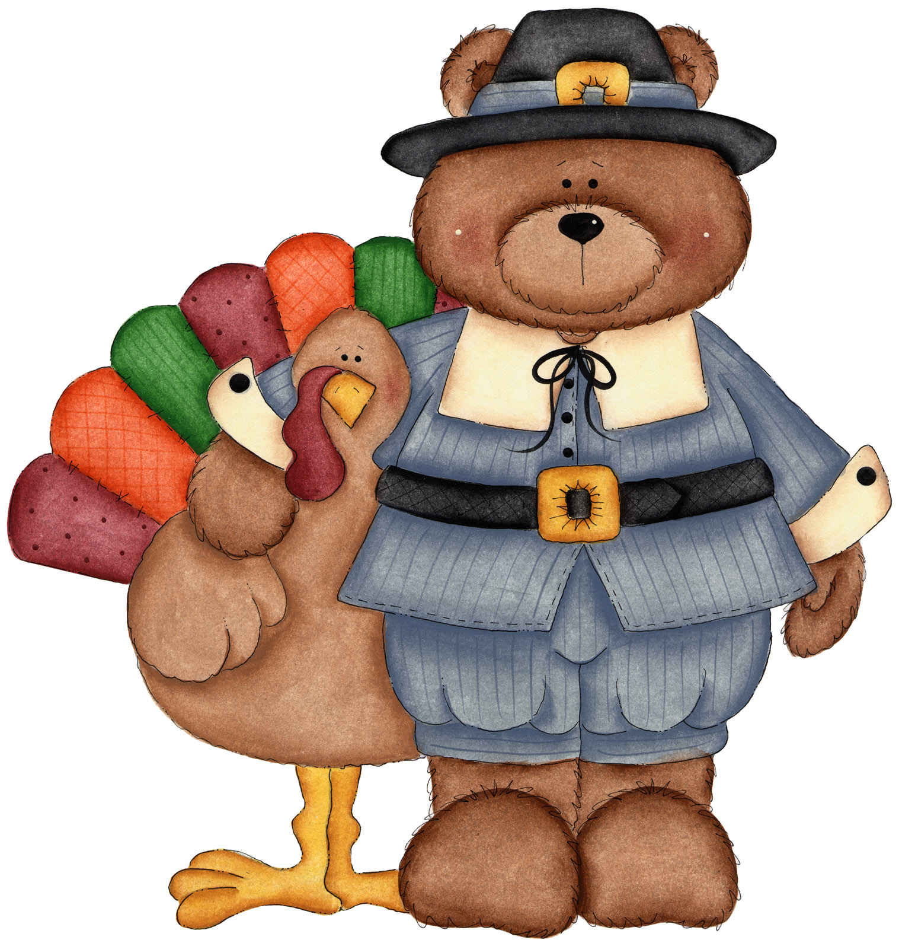
Happy Thanksgiving!
“Give thanks to the Lord, for He is good; His love endures forever.” Psalm 107:1

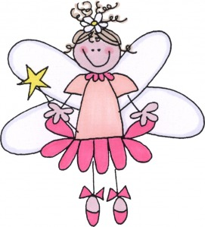www.happyhomefairy.com

