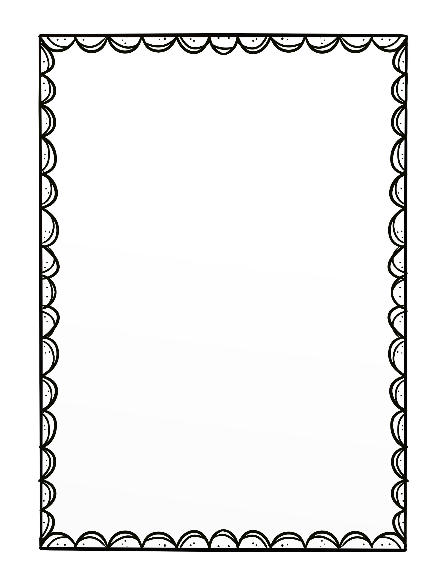

Say Yes to the Dress!

Design a dress for the bride that best reflects her personality.

The bride will pick her favorite!